October 2, 2025

The Honorable Mehmet Oz, M.D. Administrator
Centers for Medicare & Medicaid Services 7500 Security Boulevard
Baltimore, MD 21244
The Honorable Russell Vought Director, Office of Management and Budget
Executive Office of the President 725 17th Street, NW Washington, DC 20503

Dear Administrator Oz and Director Vought:

We write to express our concerns regarding the Centers for Medicare & Medicaid Services' (CMS) proposed Calendar Year (CY) Home Health proposed rule’s inclusion of ostomy, urological, and tracheostomy supplies in the Durable Medical Equipment, Prosthetics, Orthotics, and Supplies (DMEPOS) Competitive Bidding Program. We respectfully request that the proposal for inclusion of these products be withdrawn as we believe it would conflict with the Administration's goals to strengthen American manufacturing, secure our medical supply chains from foreign adversaries, and protect the health and well-being of our nation's most vulnerable citizens.

Our offices have received numerous communications from constituents, including seniors who rely on these critical prosthetic devices daily to maintain their employment, independence, health, and dignity. These individuals, and the doctors and nurses who care for them, understand better than anyone that ostomy, urological, and tracheostomy supplies are not commodity items that should be subjected to a "lowest bidder" procurement model. They are highly individualized prosthetics, which replace or restore critical bodily functions. The precise fit and clinical appropriateness of these products are matters of life and death for millions of Medicare beneficiaries.

We firmly believe in the Administration's commitment to American manufacturing and supply chain independence. In the U.S. today, manufacturing of ostomy, urological and tracheostomy products is in further need of growth and support. To bid these items sends the wrong message to our U.S. manufacturers who employee engineers, researchers, and product developers and
U.S. suppliers who employ thousands of workers in good-paying jobs, contributing to local economies in rural and other communities across the nation. Competitive bidding threatens to destroy many of these businesses overnight, transferring this market to foreign competitors who have no commitment to American workers, American communities, or American patients.

We are equally concerned the proposal does not consider the economic impact that would result from health consequences if these prosthetic products are included in the competitive bidding program. Ostomy, urological, and tracheostomy supplies represent a relatively small portion of overall Medicare spending, and these products, despite their significance for patients, are low cost. Any savings that might possibly be achieved through competitive bidding will be more

than offset by the increased costs associated with managing health care complications, serious kidney and skin infections, emergency department visits, and hospitalizations that inevitably result when patients receive inappropriate or poorly-fitted devices.

With this feedback, we respectfully urge the Administration to withdraw this proposal and instead focus on targeted enforcement measures to address any fraudulent Medicare providers while preserving patient access to all clinically appropriate prosthetic devices from qualified American businesses. We look forward to continuing to work with the Administration to protect both our domestic medical supply chain and the health and dignity of millions of Medicare beneficiaries who depend on these essential prosthetic products. Together we can ensure that Medicare policy always reflects the Administration's core principles of America First, patient choice, and clinical excellence.

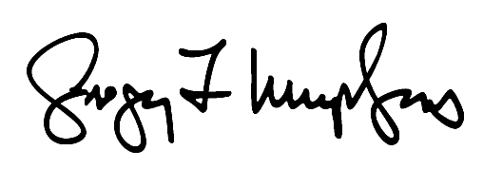
Sincerely,

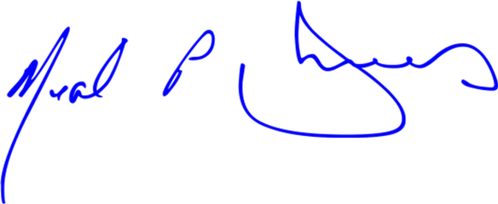
Neal P. Dunn, M.D. Member of Congress
Gregory F. Murphy, M.D. Member of Congress

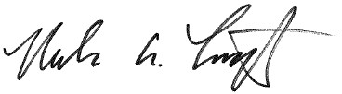

Eleanor Holmes Norton Member of Congress
Nicholas A. Langworthy Member of Congress

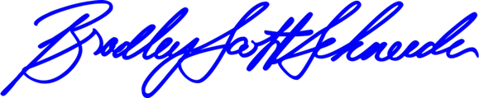
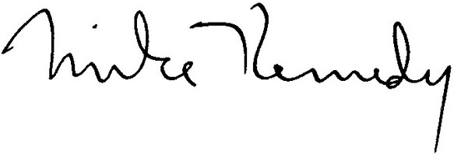
Bradley Scott Schneider Member of Congress

Mike Kennedy, M.D. Member of Congress

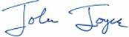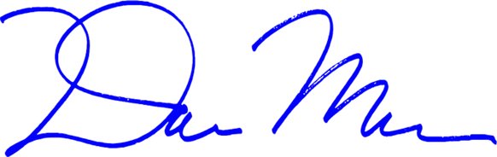

John Joyce, M.D.
Member of Congress
Dan Meuser
Member of Congress

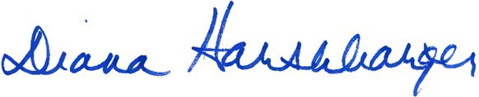

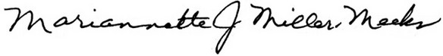
Mariannette J. Miller-Meeks,
M.D.
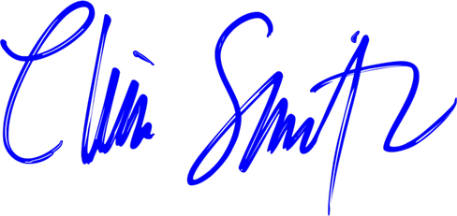
Member of Congress
Diana Harshbarger, Pharm.D.
Member of Congress

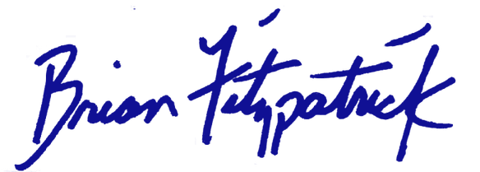
Brian K. Fitzpatrick Member of Congress
Christopher H. Smith Member of Congress



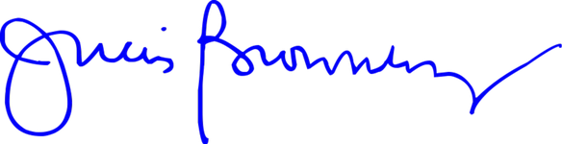
Julia Brownley
Member of Congress
Randy Feenstra
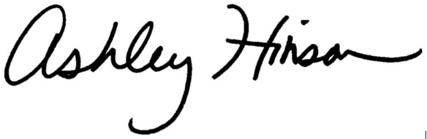
Member of Congress

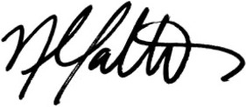
Nicole Malliotakis Member of Congress
Ashley Hinson Member of Congress

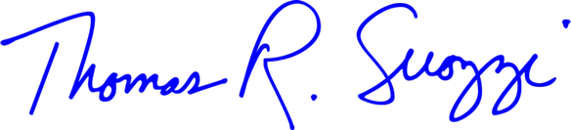

Thomas R. Suozzi
Member of Congress
Troy Balderson
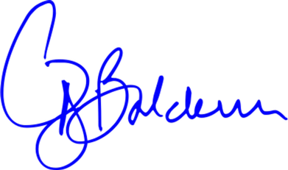
Member of Congress



Jefferson Van Drew
Member of Congress
Kat Cammack
Member of Congress

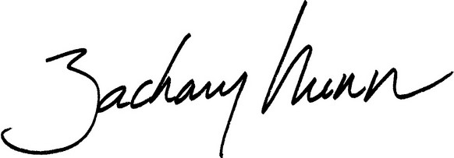
Zach Nunn
Member of Congress
Mike Kelly

Member of Congress



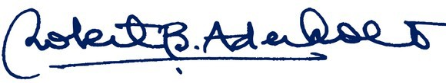
Robert B. Aderholt
Member of Congress
Mike Carey
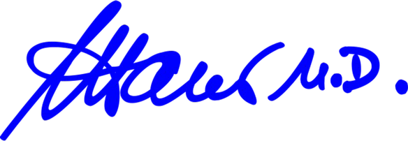
Member of Congress


Dan Crenshaw Member of Congress
Andy Harris, M.D. Member of Congress

